SCHOOL OF COMPUTING
COMMON INFOCOMM TECHNOLOGY PROGRAMME
DIPLOMA IN APPLIED AI & ANALYTICS
DIPLOMA IN INFOCOMM SECURITY MANAGEMENT
DIPLOMA IN INFORMATION TECHNOLOGY

ST0502 Fundamentals of Programming

2022/2023 SEMESTER 1
PRACTICAL ASSIGNMENT (CA2)

Instructions and Guidelines:

- CA2 an individual assignment that accounts for 30% of the module. It comprises of 2 parts ie Stage 1 & Stage 2 requirements.

- You are required to submit softcopy source codes for both Stages 1 & 2 in BrightSpace by the deadlines given below.

In your submission, please include a short header wth your Name (as in SAS2), Class and Admission number in your program.

Sample header:
// Name : King Arthur
// Class: DCCC/1A/03
// Adm : 889977
//
:
:

CA2 | Submission Deadline in eSP(BrightSpace) | Marks Allocation
Part 1 | 4 July 2022 (Mon), 8am (Week 12) | 20
Part 2 | 1 Aug 2022 (Mon), 8am (Week 16) | 80
 | Total | 100

- You must use JavaScript to develop the application in Visual Studio Code.

- You may consult your Lecturer for overall design and structure of your assignment. However, you are NOT allowed to ask him/her to debug your program. Students who seek debugging help from Lecturer will only be awarded a maximum grade of C+. It can be lower depending on the quality of work submitted.

- You are required to do demo/interview of your programs to your Lecturer individually. You may be asked to explain the program logic during the sessions. Please check with your Lecturer for the detailed schedule.

- If you are absent from the demo/interview without a valid Leave of Absence approved by SP, you will be awarded ZERO mark even if you have submitted your assignments. If you are not well on your day of interview and have an approved Leave of Absence (LOA), you have to inform you Lecturer in advance, apply for LOA in Student portal and submit a copy of the approved Leave of Absence by email to your lecturer. Your Lecturer will arrange for a make-up interview session.

- 50% of marks to be deducted for submission of assignment within ONE calendar day after the deadline. No marks shall be awarded for assignments submitted more than one day after the deadline.

For example : If the submission deadline is 1 Jan, 8am, any submission after that till 2 Jan, 8am will have 50% marks deducted. Any submisson from 3 Jan, 8am onwards will NOT be accepted ie given zero.

- No marks will be awarded, if the work is copied, done by someone or you have allowed others to copy your work. This is a very serious offence of plagiarism committed by all involved (ie all the givers & receipients). Please refer the clause in RED below regarding plagiarism.

Warning: Plagiarism means passing off as one's own the ideas, works, writings, etc., which belong to another person. In accordance with this definition, you are committing plagiarism if you copy the work of another person and turning it in as your own, even if you would have the permission of that person. Plagiarism is a serious offence and disciplinary action will be taken against you. If you are guilty of plagiarism, you may fail all modules in the semester, or even be liable for expulsion.

Requirements for Shoppers Membership Application (Pilot)

- Objective

The objective of this assignment is to create a pilot shoppers membership loyalty application.

- Overview

Company XYZ plans to launch a membership loyalty program to boost the sales of its products. The CEO has hired you to create a pilot application with a few features to test out this new idea. These are piloted in two stages i.e. if the first stage is successful, they will proceed to Stage 2. Depending on the outcomes, the CEO will then consider developing the full application.

There are 3 types of memberships: Diamond, Gold and Ruby. For each purchase made, loyalty points are awarded based on the amount purchased by the members.

- Stage One Requirements

You are to complete all the Stage 1 requirements below, submit your codes and do a 5~7mins demo to your lecturer.

3a. Declare and initialize 5 arrays to represent the 5 different members consisting of the following properties. Subsequently, declare another array – memberList to store all the arrays. You may refer to the additional resources provided to perform the aforementioned task.

Name | Leonardo | Catherine | Luther | Bruce | Amy
Membership Type | Gold | Ruby | Gold | Diamond | Ruby
Date Joined | 1 Dec 2019 | 14 Jan 2020 | 29 Apr 2020 | 3 Jun 2020 | 5 Jun 2020
Date of Birth | 1 Jan 1980 | 28 Oct 1985 | 16 Mar 1992 | 18 Mar 1994 | 31 May 2000
Points Earned | 1400 | 250 | 3350 | 40200 | 500

3b. Create a menu to display members’ details. The output below illustrate the application when executed.

You are to follow the text display as shown in ALL output. You must ask for user’s name and display it on screen.

The program should allow user to choose the other options without terminating the program. The program should terminate only when EXIT is selected.

Validation of all data input is required.
Refer to the following screenshots for more details. Text in red boxes denotes user’s input. You are NOT required to display the red box in your output.
Sample output to prompt for user’s name and display the menu options.
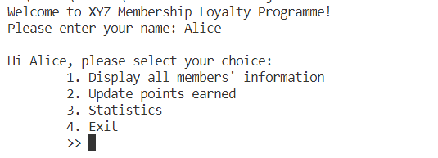

Sample output when an invalid input is entered. Re-prompt user for a valid input.
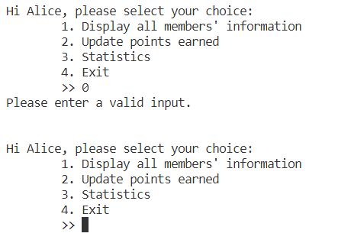

Sample output when either options (2) or (3) is entered. It displays a message and re-prompt user for input.
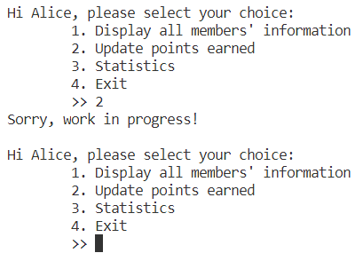

Sample output when option (1) is entered. It displays all members information and re-prompt user for input.
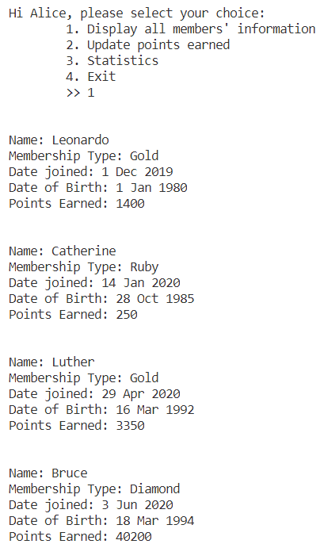
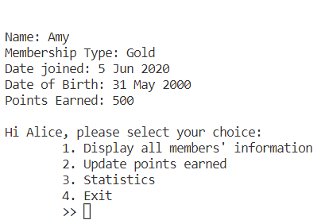

Sample output when option (4) is entered, it displays a message and the program is terminated.
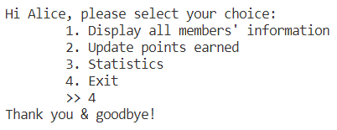

3c. Assessment Criteria (20marks)

Marks are allocated based on the following criteria. Students may be asked to explain codes during the demo session.

- Proper declaration of arrays
- Program produces correct output according to requirements
- Data validation is correct and complete
- Program executes properly without crashing/errors produced and terminates properly

- Stage TWO Requirements

After the Company XYZ saw your demonstration, they were very happy with your work but had some suggestions for the application.

First of all, you are to upgrade the current application using the object oriented concept learnt in the module. In which, you should not be storing the member’s information using arrays but through usage of classes and objects.

Company XYZ was kind enough to suggest that the application should consist of at least 2 of the following classes i.e.

- Member class to define each member’s properties and methods. Properties includes:
- Name
- Membership type (Diamond, Platinum, Gold or Ruby)
- Date joined
- Date of birth
- Points earned

- MemberGroup class to represent an array of all members, other properties and methods.
- Feel free to add any properties, other classes or methods you feel are needed in your program.

Hence, the first step was to use objects/classes to create the 5 members consisting their respective properties.
Validation of all data input is required unless otherwise stated in the requirements.

4a. Next, Company XYZ proposed to increase the choices in the main menu to cater for more options as follows:

Refer to the following screenshots for more details. Text in red boxes denotes user’s input. You are NOT required to display the red box in your output.
Sample output to prompt for user’s name and display the menu options.

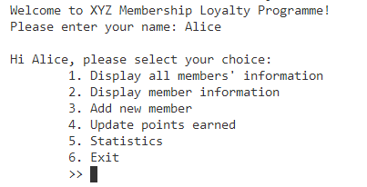
4b. When the user selects option 2 – Display member information, the program will prompt the user to enter the name of the member to display information.
Sample output when option 2 is entered. Prompt user to enter member’s name.
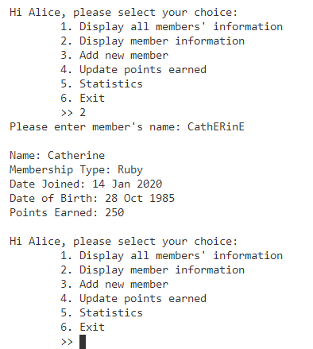

Sample output when invalid name is entered. Brings user back to main menu.
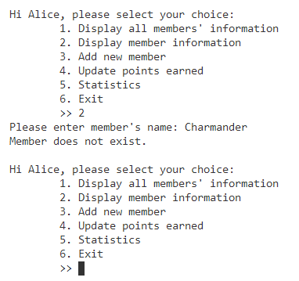

4c. When the user selects option 3 – Add new member, the program will prompt user to enter the name of the new member and the date of birth.
Sample output when option 3 is entered. Prompt user to enter new member’s name and date of birth. You may assume the user will enter a valid date of birth ONLY.
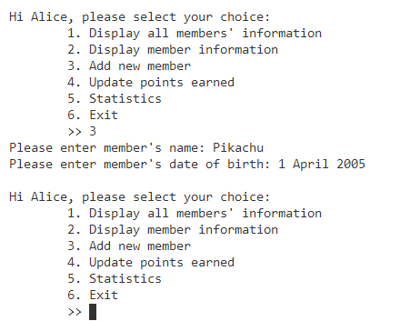

Sample output when name already in database. Re-prompt user to enter a new name.
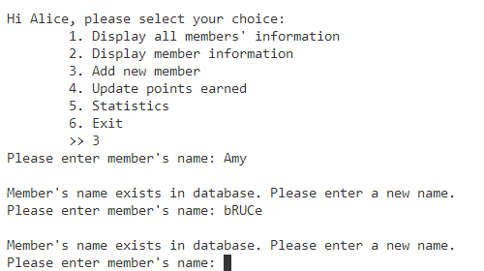

4d. When the user selects option 4 – Update points earned, the program will prompt user to enter the name of the member and the amount spent. The table below shows the points earned by the member based on the amount spent.

Amount Spent | Points Earned
Less than or equal to $50 | 10
$50.01 to $100 | 50
$100.01 to $200 | 100
$200.01 to $500 | 200
$500.01 to $1000 | 500
$1000.01 to $2500 | 1000
$2500.01 and above | 2000

Sample output when option 4 is entered. Prompt user to enter member’s name and amount spent.
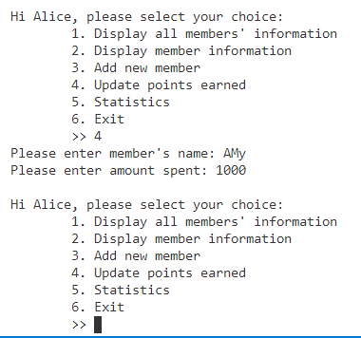

Sample output when name does not exist in database. Prompt user back to the main menu.
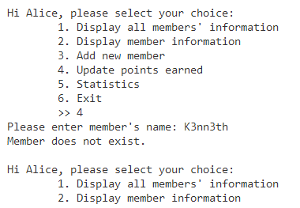

NOTE: The default membership type for all newly joined members is ‘Ruby’. If the member manages to accumulate above certain amount of points, his/her membership type will be upgraded to the next tier. Your program should automatically upgrade the membership type upon reaching the respective points.

Membership Type | Minimum Points to achieve
Diamond | 20000
Platinum | 5000
Gold | 500
Ruby (Default) | 0

4e. When the user selects option 5 – Statistics, the program will display a sub menu shown below.
Sample output when option 5 is entered. A sub menu is displayed and prompts user for an option.

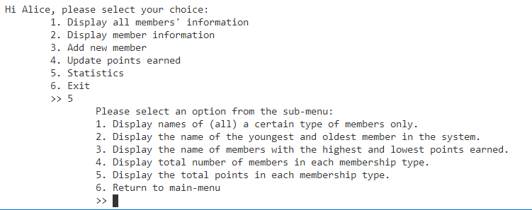

Sample output when option 1 of the sub menu is entered. Prompt user for Membership Type until a valid Membership Type is entered.

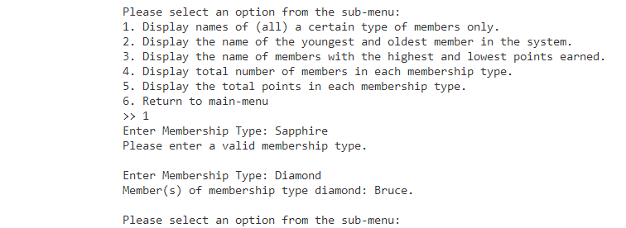

Sample output when option 2 of the sub menu is entered.

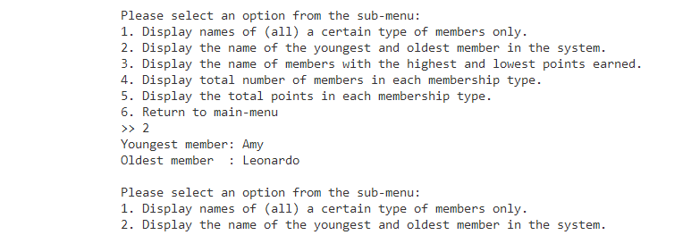

Sample output when option 3 of the sub menu is entered.

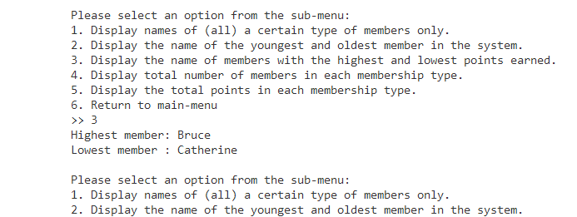

Sample output when option 4 of the sub menu is entered. Do note that your result may differ from the sample output due to different test cases involved.

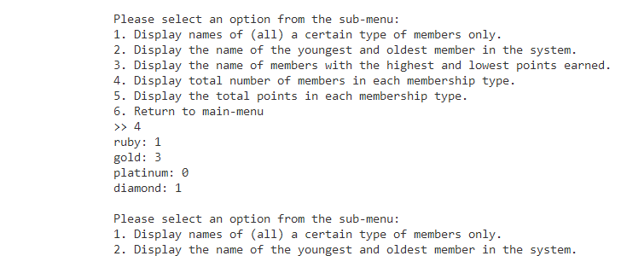
Sample output when option 5 of the sub menu is entered. Do note that your result may differ from the sample output due to different test cases involved.

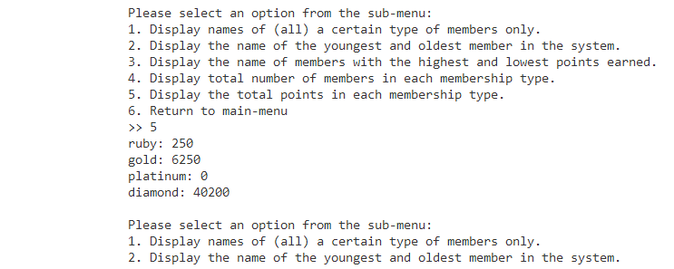

Sample output when option 6 of the sub menu is entered.

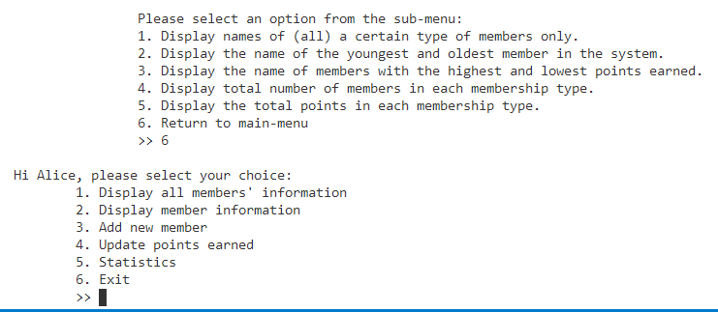

4. Assessment Guidelines

Marking criteria will be based on student’s ability to demonstrate program requirements and explanation demonstration and Q&A interview in the following areas:

Assessment Criteria | Maximum marks allocated
Program functionalities (Part 1)  - Execute basic requirements mentioned above correctly  - Include appropriate validations | 20
Program functionalities (Part 2)  - Execute basic requirements mentioned above correctly  - Include appropriate validations | 45
Program design:  - Correct and efficient usage of classes and programming constructs  - Appropriate method decomposition  - Proper use of Arrays, Functions, Loops, if-else etc  - Code efficiency  Program readability:  - Meaningful identifiers  - Meaningful comments and indentation in source documentation | 20
Innovation and creativity or any advanced features | 15
Total | 100

-- End --

